
K J Somaiya Institute of Technology
An Autonomous Institute Permanently Affiliated to the University of Mumbai DEPARTMENT OF INFORMATION TECHNOLOGY
Name of Student : Aditya Bali
Roll No : B - 71
Batch : SB4
EXPERIMENT 8
Aim:
Implementation of any one Sorting Technique considering a real-world application.)
Objective :
● To implement the Selection Sort algorithm using C programming. ● To accept temperature readings from the user for different weather stations. ● To arrange temperature readings in ascending order.
● To understand the sorting process and its application in temperature monitoring systems.
Software Used:
● Turbo C / Turbo C++
● DOSBox
Theory :
Selection Sort is a simple sorting technique that repeatedly selects the smallest element from the unsorted portion of an array and places it in its correct position. In this application, the temperature readings collected from different weather stations are stored in an array. The algorithm compares the readings, identifies the minimum temperature, and swaps it with the first unsorted element. This process continues until all readings are arranged in ascending order.
Program :
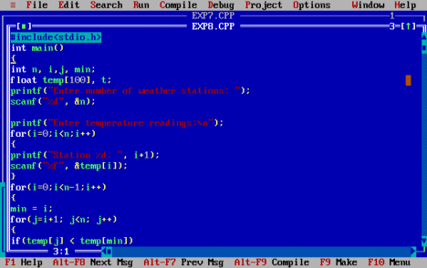
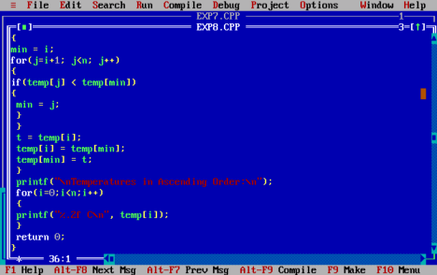
Output :
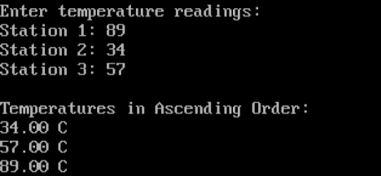
Algorithm :
1. Start.
2. Accept the number of weather stations, n.
3. Input the temperature readings into an array.
4. Set the current index i to zero.
5. Find the minimum temperature in the unsorted portion of the array. 6. Swap the minimum temperature with the element at index i.
7. Repeat the process for the remaining unsorted elements.
8. Display the sorted temperatures in ascending order.
9. Stop.
Outcome :
Selection Sort was successfully implemented in C to accept temperature readings from the user and arrange them in ascending order.
Conclusion :
Thus, the Selection Sort algorithm was successfully implemented for a real-world temperature monitoring application. It helps organize temperature readings from multiple weather stations from the lowest to the highest value.

